Detail Design Document(Application)

V 1.0

Huaizhong Liu Ardy Yan



Sep. 28, 2001
Document Control

Change Record

Date | Author | Version | Change Reference
09/28/2001 | Huaizhong Liu | 1.0

Reviewers

Date | Name | Position
9/27/2001 | Eric | Tech Lead
9/27/2001 | Huaizhong Liu, Ardy Yan | DV
9/27/2001 | Robin | Architecture
9/27/2001 | Jack | Architecture
9/27/2001 | Cedric | QA

Approved By

Name | Position | Signature | Date

Table of Contents
Table of Contents 1
Logical View 5
com 5
dc 5
eschool 5
Exam 5
ExamCancel 10
ExamEnd(T) 11
ExamGroup 11
ExamSelect 13
ExamStart(S) 14
ExamStart(T) 14
Examination 15
FileAccese 16
IExam 17
Student 20
StudentGroup 21
StudentGroupIF 21
StudentImpl 22
Teacher 22
TeacherImpl 22
answerExam 23
Inspection 24
CallingDialog 29
IInspection 29
Inspection 31
ShowWarnDialog 32
WarnDialog 32
System 33
CourseInfo 36
EJBAccese 37
ICourse 39
IUser 40
SystemExit 42
UserInfo 42
SystemControl 43
AnswerExamFrm 44
ClassCinemaFrm 45
CommunicationIF 45
ExamGroupFrm 45
JMFIF 45
ListeningIF 45
LoginIF 45
MainFrm 46
NewClass 46
PlayListenFrm 46
QuestionStudent 46
QuestionTeacher 46
SelectListenFrm 46
StudentGroupFrm 47
SystemControl 47
Talk 48
eschool 48
Communication 48
ChatClient 59
ChatServer 60
CommunicationStudent 60
CommunicationStudentIF 60
CommunicationTeacher 61
CommunicationTeacherIF 61
FileAccess 62
Group 63
GroupIF 63
GroupTalking 64
JMFstudent 64
JMFstudentIF 65
JMFteacher 65
JMFteacherIF 65
MultimediaSender 65
QuestionandAnswer 66
TalkwithTeacher 66
groupDO 66
Listening 67
ListenDisplay 68
ListenServer 68
Listeningstudent 69
ListeningstudentIF 69
Listeningteacher 69
ListeningteacherIF 70
listeningDO 70
System 72
Login 73
LoginIF 74
Student 74
StudentImpl 76
Teacher 76
TeacherImpl 77
UserInfo 78
ejbAccess 78
opDO 79
uidesign 80
AnswerExamFrm 81
ClassCinemaFrm 82
ExamGroupFrm 84
PlayListenFrm 86
QuestionStudent 88
QuestionTeacher 88
SelectExamFrm 89
SelectLinstenFrm 90
StudentGroupFrm 92
Talk 95
WarnDialog 96
mainFrame 97

Logical View Report

Logical View

Class Diagram - Main

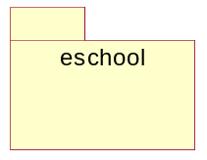

com

dc

eschool

Exam

Class Diagram - Exam

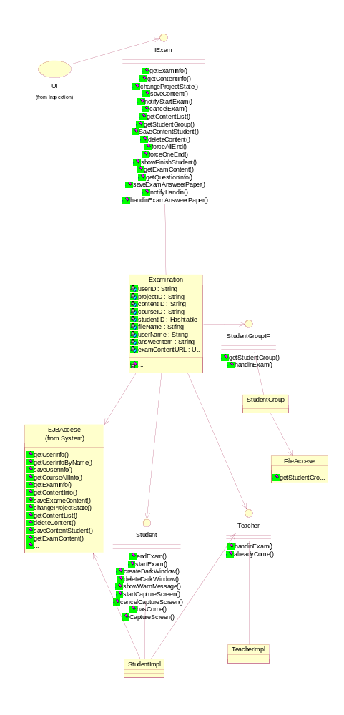

Interaction Diagram - chooseExam

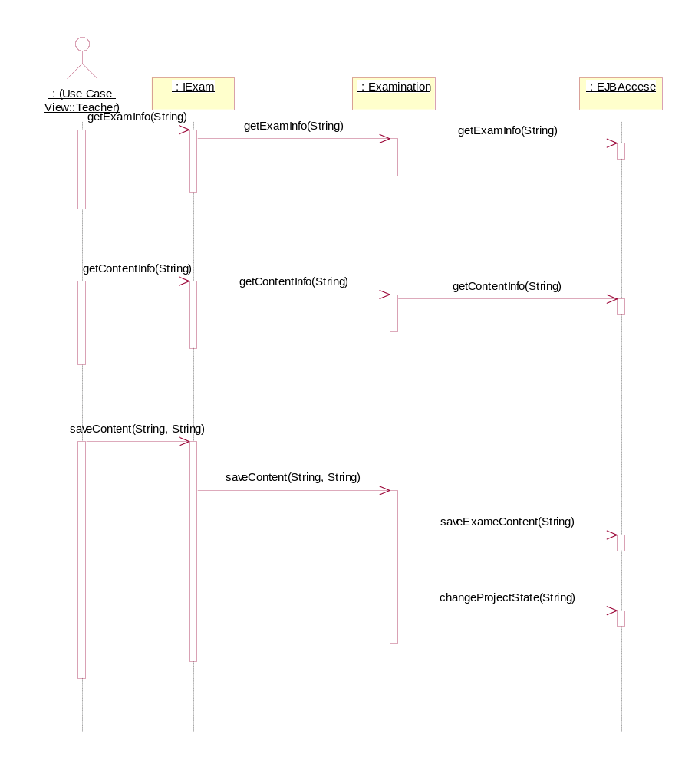

Interaction Diagram - ExamGroup

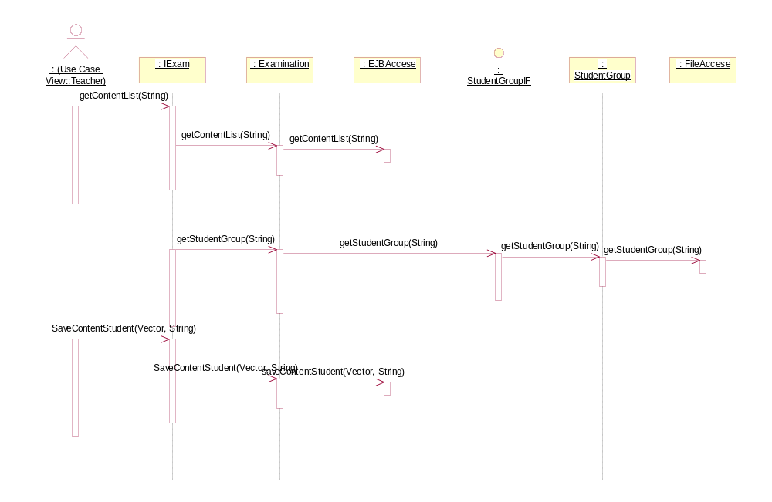

Interaction Diagram - StartExam&GetContent

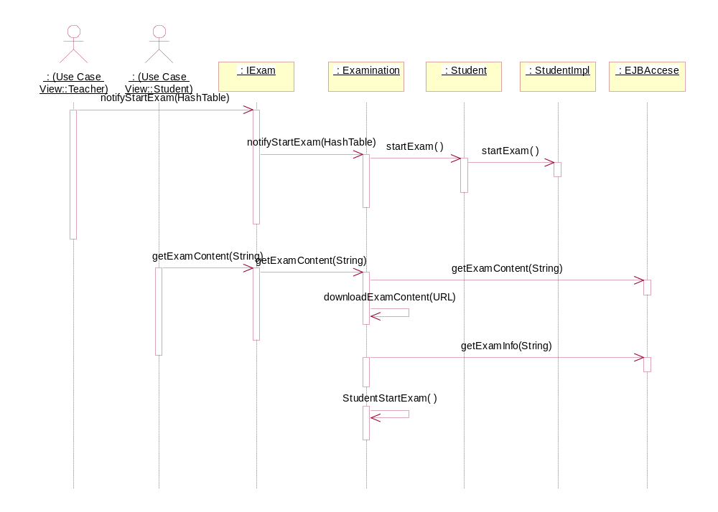

Interaction Diagram - EndExam

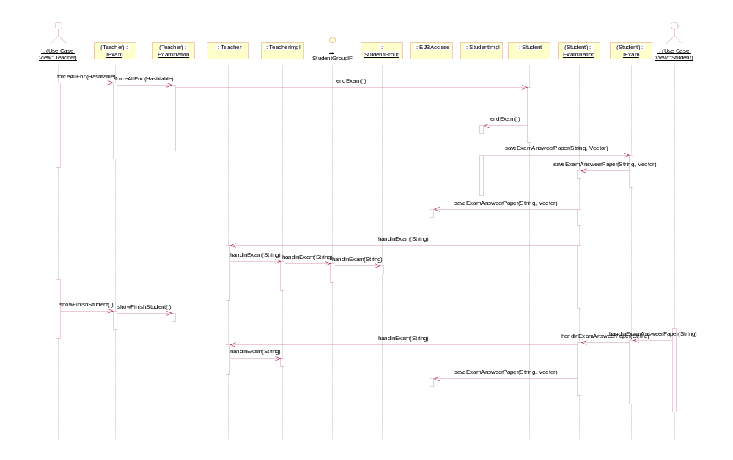

ExamCancel

取消考试

Private Attributes:

userID : String

用户ID

Associations:

(Unnamed Target Role) [] : Unnamed Association (Unnamed Supplier Role) to IExam

Public Operations:

cancelExam ( userID : String) : String

取消考试

userID

ExamEnd(T)

结束考试

Private Attributes:

userID : String

用户ID

studentID : Hashtable

userName : String

Associations:

(Unnamed Target Role) [] : Unnamed Association (Unnamed Supplier Role) to IExam

Public Operations:

forceAllEnd () : Boolean

调用学生类远程方法，强行收卷

forceOneEnd ( userName : String) : Boolean

调用学生类的远程方法，结束一个学生的考试。

userName

showFinishStudent () :

显示交卷的学生

ExamGroup

试题分组

Private Attributes:

userID : String

用户ID

contentID : String

试题ID

fileName : String

文件名

Associations:

(Unnamed Target Role) [] : Unnamed Association (Unnamed Supplier Role) to IExam

Public Operations:

getContentList ( userID : String) : ResultSet

获得备选试题信息

userID

getStudentGroup ( fileName : String) : Vector

读取分组

fileName

saveContentStudent ( userID : Vector, contentID : String) : Boolean

设置学生的试题

userID

contentID

deleteContent ( contentID : String) : Boolean

删除试题

contentID

ExamSelect

试题选择

Private Attributes:

userID : String

用户ID

projectID : String

考试ID

contentID : String

试题ID

courseID : String

Associations:

(Unnamed Target Role) [] : Unnamed Association (Unnamed Supplier Role) to IExam

Public Operations:

getExamInfo ( userID : String) : ResultSet

获得考试的相关信息

userID

getQuestionInfo ( projectID : String) : ResultSet

获得考试对应试题的相关信息

projectID

changeProjectState ( ProjectID : String) : Boolean

修改相应考试的状态。

ProjectID

saveContent ( contentID[] : String) : Boolean

contentID[]

ExamStart(S)

开始考试（学生方）

Private Attributes:

userID : String

用户ID

Associations:

(Unnamed Target Role) [] : Unnamed Association (Unnamed Supplier Role) to IExam

Public Operations:

getExamContent ( userID : String) : Object

获得考试题，开始考试

userID

getQuestionCount ( userID : String) : int

userID

ExamStart(T)

开始考试（老师方）

Private Attributes:

userID : String

用户ID

studentID : Hashtable

学生信息

Associations:

(Unnamed Target Role) [] : Unnamed Association (Unnamed Supplier Role) to IExam

Public Operations:

notifyStartExam ( studentID : Hashtable) : Boolean

远程方法调用，调用学生的方法通知学生考试开始。

studentID

Examination

该类实现了ExamIF接口，并且调用EJBAccess与数据库通信，调用FileAccese与本地文件通讯。

Private Attributes:

userID : String

用户ID

projectID : String

考试ID

contentID : String

试题ID

courseID : String

课程ID

studentID : Hashtable

学生ID散列表

fileName : String

userName : String

answeerItem : String

examContentURL : URL

Associations:

(Unnamed Target Role) [] : Unnamed Association (Unnamed Supplier Role) to EJBAccese

(Unnamed Target Role) [] : Unnamed Association (Unnamed Supplier Role) to Student

(Unnamed Target Role) [] : Unnamed Association (Unnamed Supplier Role) to Teacher

(Unnamed Target Role) [] : Unnamed Association (Unnamed Supplier Role) to StudentGroupIF

Private Operations:

downloadExamContent ( examContentURL : URL) : Object

examContentURL

StudentStartExam () :

学生开始考试，学生会利用得到的考卷和试题信息自动生成考卷。

FileAccese

来读取和保存本地学生分组文件

Associations:

(Unnamed Target Role) [] : Unnamed Association (Unnamed Supplier Role) to StudentGroup

Public Operations:

getStudentGroup ( fileName : String) : Hashtable

取得学生分组信息

fileName

IExam

考试的界面接口，它定义的方法由Examination类来实现。它定义了所有与考试有关的界面方法。

Associations:

(Unnamed Target Role) [] : Unnamed Association (Unnamed Supplier Role) to ExamSelect

(Unnamed Target Role) [] : Unnamed Association (Unnamed Supplier Role) to ExamStart(T)

(Unnamed Target Role) [] : Unnamed Association (Unnamed Supplier Role) to ExamCancel

(Unnamed Target Role) [] : Unnamed Association (Unnamed Supplier Role) to ExamGroup

(Unnamed Target Role) [] : Unnamed Association (Unnamed Supplier Role) to ExamStart(S)

(Unnamed Target Role) [] : Unnamed Association (Unnamed Supplier Role) to answerExam

(Unnamed Target Role) [] : Unnamed Association (Unnamed Supplier Role) to ExamEnd(T)

(Unnamed Target Role) [] : Unnamed Association (Unnamed Supplier Role) to UI

(Unnamed Target Role) [] : Unnamed Association (Unnamed Supplier Role) to SystemControl

Public Operations:

getExamInfo ( CourseID : String) : ResultSet

获得考试的相关信息

CourseID

getContentInfo ( projectID : String) : ResultSet

获得考试对应试题的信息

projectID

changeProjectState ( projectID : String) :

修改考试的状态

projectID

saveContent ( contentID[] : String, projectID : String) :

保存试题

contentID[]

projectID

notifyStartExam ( studentID : HashTable) :

通知考试的学生考试开始。

studentID

cancelExam ( userID : String) :

老师取消考试

userID

getContentList ( userID : String) : ResultSet

取得考试题列表

userID

getStudentGroup ( fileName : String) : Hashtable

获得学生的分组

fileName

SaveContentStudent ( userID : Vector, contentID : String) :

保存试题分组信息

userID

contentID

deleteContent ( contentID : String) :

删除试题

contentID

forceAllEnd ( studentID : Hashtable) :

调用学生类的远程方法，强行收卷

studentID

forceOneEnd ( userName : String) :

调用学生端的远程方法，强行收某一学生的试卷

userName

showFinishStudent () :

显示已经交卷的学生

getExamContent ( userID : String) : URL

学生获得考试题

userID

getQuestionInfo ( userID : String) : Vector

得到试题的数目，用来生成学生考试界面

userID

saveExamAnsweerPaper ( userID : String, answeerItem : Vector) :

保存考试结果

userID

answeerItem

notifyHandin ( userName : String) :

调用远程方法，通知老师注意到自己已经交卷。

userName

handinExamAnsweerPaper ( userID : String) :

试题交卷，该方法要调用saveResult方法，另外还要调用notifyHandin方法，通知老师。

userID

Student

学生远程接口

Associations:

(Unnamed Target Role) [] : Unnamed Association (Unnamed Supplier Role) to Examination

(Unnamed Target Role) [] : Unnamed Association (Unnamed Supplier Role) to Inspection

(Unnamed Target Role) [] : Unnamed Association (Unnamed Supplier Role) to WarnDialog

Public Operations:

endExam () :

结束考试

startExam () :

开始考试

createDarkWindow () :

在学生界面上创建黑色的窗口，来覆盖所有的操作区域，也就时禁止学生对Application的所有操作。

deleteDarkWindow () :

删除已经存在的黑色窗口，学生的操作界面恢复正常。

showWarnMessage ( warnContent : Stirng) :

创建一窗体，显示警告信息

warnContent

startCaptureScreen () :

老师会调用该方法开始抓屏，该方法会调用CreatePlayer(),broadcastPlayer()方法协调完成学生端的广播。

cancelCaptureScreen () :

取消抓屏

hasCome () :

询问学生是否在听课，该方法会调用一个对话框，显示老师的提示。

CaptureScreen () : Object

抓取学生的屏幕

StudentGroup

这是StudentGroupIF的实现类。

Associations:

(Unnamed Target Role) [] : Unnamed Association (Unnamed Supplier Role) to FileAccese

StudentGroupIF

这是实现分组的接口

Associations:

(Unnamed Target Role) [] : Unnamed Association (Unnamed Supplier Role) to Examination

(Unnamed Target Role) [] : Unnamed Association (Unnamed Supplier Role) to SystemControl

Public Operations:

getStudentGroup ( fileName : String) : Hashtable

获得学生的分组信息

fileName

handinExam ( userName : String) :

学生交卷并且刷新界面

userName

StudentImpl

学生远程接口的实现类

Associations:

(Unnamed Target Role) [] : Unnamed Association (Unnamed Supplier Role) to EJBAccese

(Unnamed Target Role) [] : Unnamed Association (Unnamed Supplier Role) to Teacher

(Unnamed Target Role) [] : Unnamed Association (Unnamed Supplier Role) to SystemControl

Teacher

老师远程接口

Associations:

(Unnamed Target Role) [] : Unnamed Association (Unnamed Supplier Role) to Examination

(Unnamed Target Role) [] : Unnamed Association (Unnamed Supplier Role) to StudentImpl

(Unnamed Target Role) [] : Unnamed Association (Unnamed Supplier Role) to Inspection

Public Operations:

handinExam ( userName : String) :

学生调用该方法，告诉老师已经交卷

userName

alreadyCome ( userName : String) :

学生调用该方法，告诉老师在认真的听讲

userName

TeacherImpl

老师远程接口的实现类

Associations:

(Unnamed Target Role) [] : Unnamed Association (Unnamed Supplier Role) to SystemControl

answerExam

学生答题

Private Attributes:

userID : String

answerItem : String

Associations:

(Unnamed Target Role) [] : Unnamed Association (Unnamed Supplier Role) to IExam

Public Operations:

saveExamAnsweerPaper ( userID : String, answerItem : String) : Boolean

保存答案至数据库

userID

answerItem

handinExamAnsweerPaper () : Boolean

试题交卷，该方法要调用saveExamAnsweerPaper方法，另外还要调用notifyHandin方法，通知老师。

notifyHandin () : Boolean

调用远程方法，通知老师注意到自己已经交卷。

Inspection

Class Diagram - Inspection

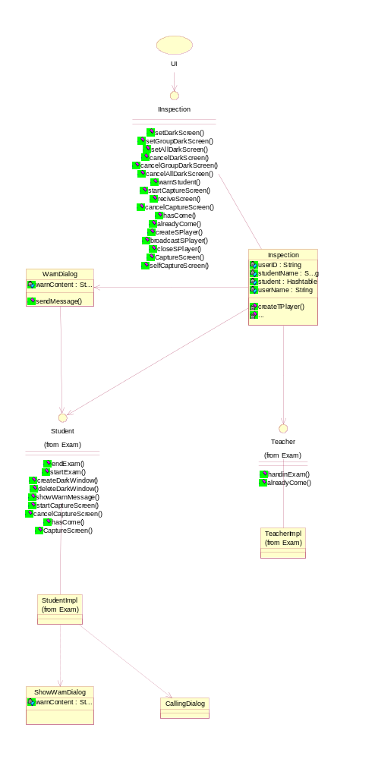

Interaction Diagram - DarkScreen

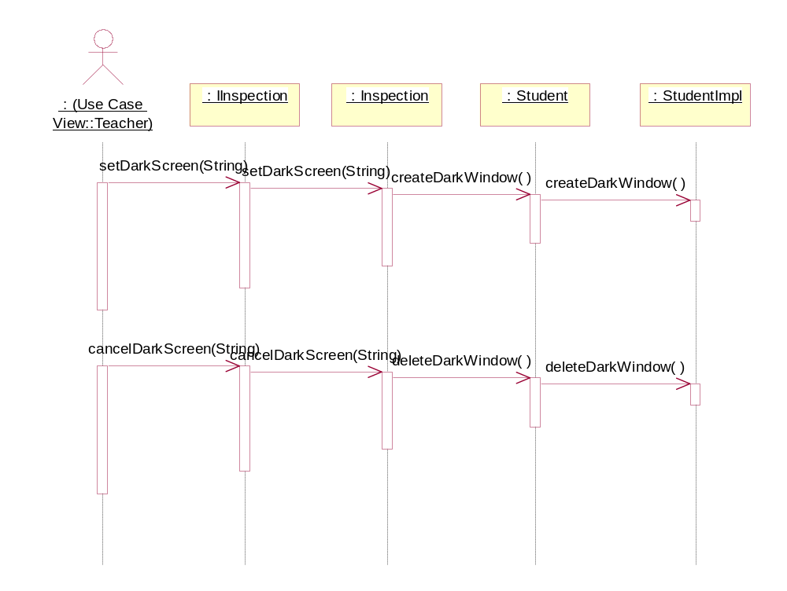

Interaction Diagram - Warning

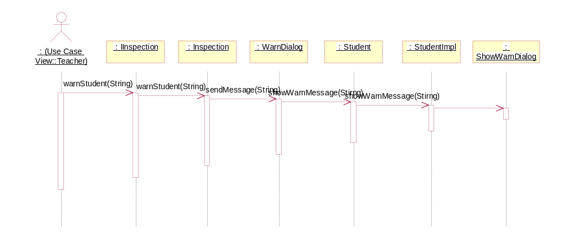

Interaction Diagram - calling

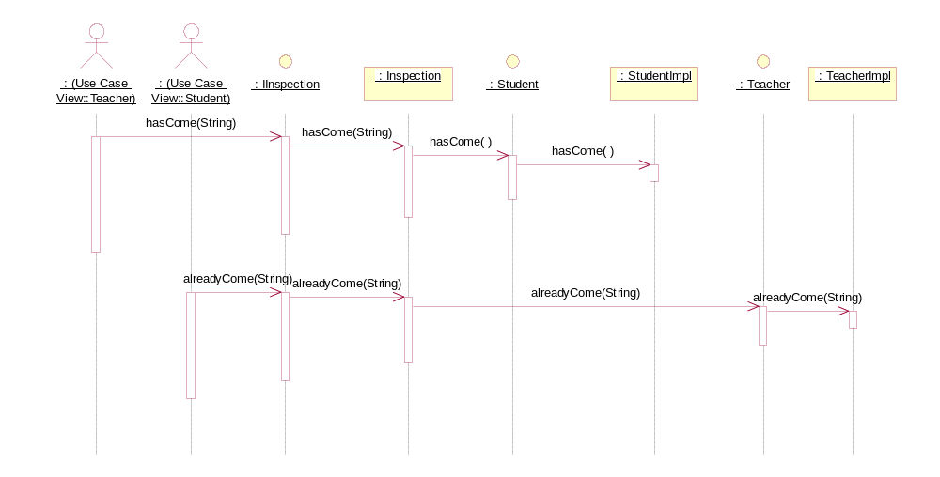

Interaction Diagram - CaptureScreen

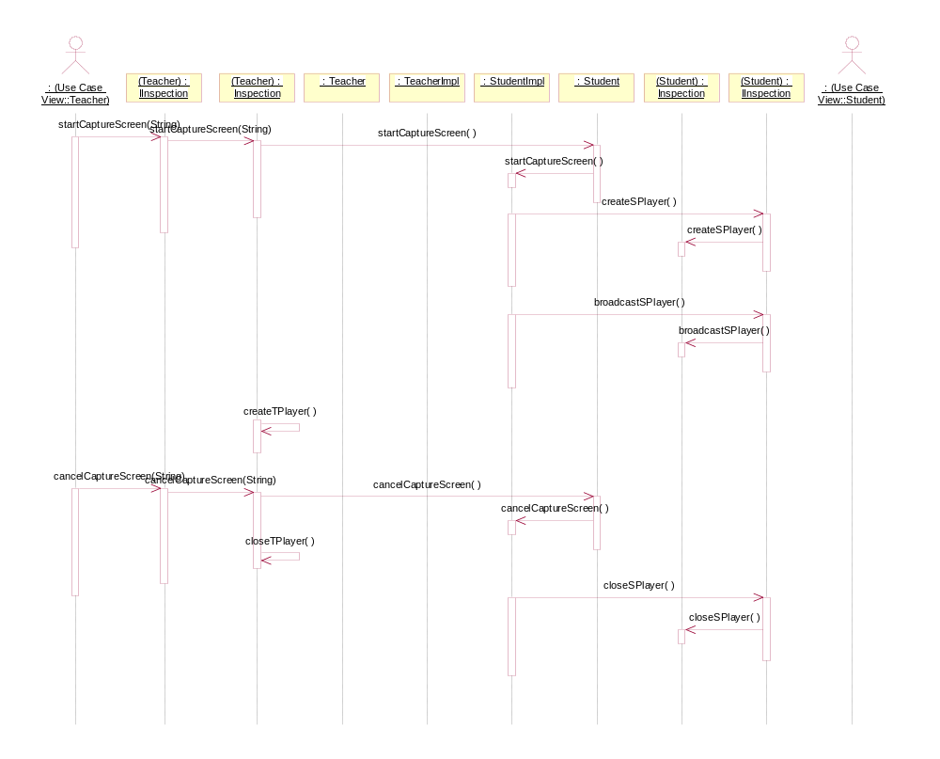

Interaction Diagram - CaptureScreen(New)

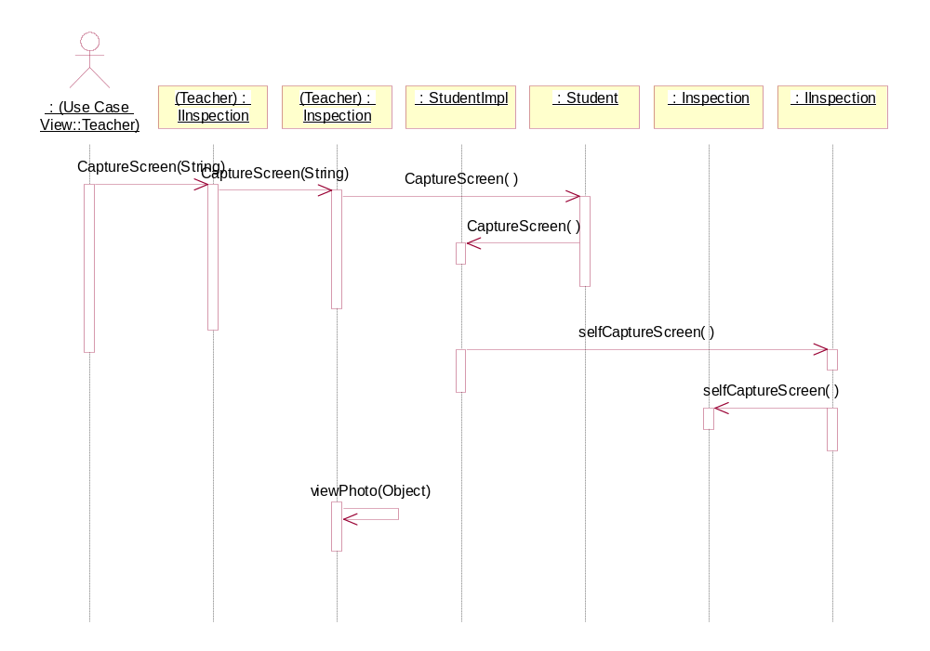

CallingDialog

老师考勤时呼叫学生的对话框

IInspection

监视接口，该接口提供了监视部分的所有方法

Associations:

(Unnamed Target Role) [] : Unnamed Association (Unnamed Supplier Role) to UI

(Unnamed Target Role) [] : Unnamed Association (Unnamed Supplier Role) to SystemControl

Public Operations:

setDarkScreen ( studentName : String) :

让某一学生黑屏

studentName

setGroupDarkScreen ( Student : Hashtable) :

让某一组或者几组学生黑屏，它会循环调用setDarkScreen(studentName:String)方法

Student

setAllDarkScreen () :

让所有学生黑屏,它会循环调用setDarkScreen(studentName:String)方法

cancelDarkScreen ( studentName : String) :

取消某一学生的黑屏

studentName

cancelGroupDarkScreen ( student : Hashtable) :

取消某一组学生的黑屏，需要循环调用cancelDarkScreen()方法

student

cancelAllDarkScreen () :

取消全体学生的黑屏，需要循环调用cancelDarkScreen()方法

warnStudent ( userName : String) :

警告某一学生

userName

startCaptureScreen ( userName : String) :

调用远程学生接口的方法开始抓屏

userName

reciveScreen ( userName : String) :

接受学生端传来的屏幕图片，并播放

userName

cancelCaptureScreen ( userName : String) :

取消学生端的抓屏程序

userName

hasCome ( userName : String) :

userName

alreadyCome ( userName : String) :

userName

createSPlayer () :

为学生端创造Player

broadcastSPlayer () :

广播学生端Player

closeSPlayer () :

关闭学生端Player

CaptureScreen ( userName : String) : Object

抓取学生的屏幕

userName

selfCaptureScreen () : Object

学生抓取自己的屏幕

Inspection

监视类，该类实现了监视接口的所有方法，并且调用其他的接口或类来协调实现。

Private Attributes:

userID : String

用户ID

studentName : String

学生名

student : Hashtable

学生信息Hashtable

userName : String

用户名

Associations:

(Unnamed Target Role) [] : Unnamed Association (Unnamed Supplier Role) to Student

(Unnamed Target Role) [] : Unnamed Association (Unnamed Supplier Role) to WarnDialog

(Unnamed Target Role) [] : Unnamed Association (Unnamed Supplier Role) to Teacher

Private Operations:

createTPlayer () :

创建老师端Player

closeTPlayer () :

关闭老师端播放器

viewPhoto ( photo : Object) :

photo

ShowWarnDialog

显示警告的对话框

Private Attributes:

warnContent : String

WarnDialog

警告信息的对话框，让老师填写警告信息。并且发送给相应的学生。

Private Attributes:

warnContent : String

警告内容

Associations:

(Unnamed Target Role) [] : Unnamed Association (Unnamed Supplier Role) to Student

(Unnamed Target Role) [] : Unnamed Association (Unnamed Supplier Role) to Inspection

(Unnamed Target Role) [] : Unnamed Association (Unnamed Supplier Role) to SystemControl

Public Operations:

sendMessage ( warnContent : String) : String

warnContent

System

Class Diagram - System

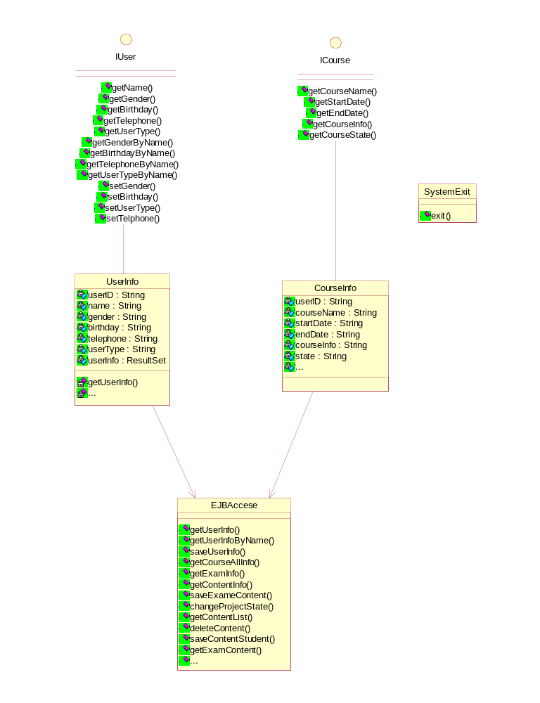

Interaction Diagram - System

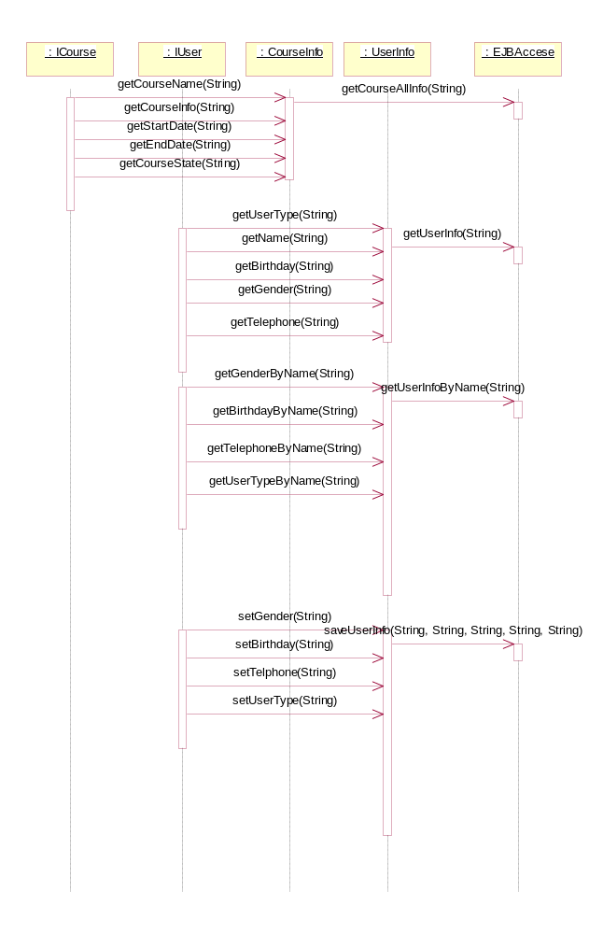

CourseInfo

获得课程的信息。

Private Attributes:

userID : String

用户ID

courseName : String

课程名称

startDate : String

开始时间

endDate : String

结束时间

courseInfo : String

课程说明

state : String

状态

courseAllInfo : ResultSet

调用EJB，获得课程的所有信息。包括课程名称，课程信息，状态以及开始日期、结束日期。

Associations:

(Unnamed Target Role) [] : Unnamed Association (Unnamed Supplier Role) to EJBAccese

Private Operations:

getCourseAllInfo ( userID : String) : ResultSet

获得课程的所有信息

userID

EJBAccese

连接EJB来得到用户所需的数据信息和修改数据库中的数据信息

Associations:

(Unnamed Target Role) [] : Unnamed Association (Unnamed Supplier Role) to Examination

(Unnamed Target Role) [] : Unnamed Association (Unnamed Supplier Role) to StudentImpl

(Unnamed Target Role) [] : Unnamed Association (Unnamed Supplier Role) to UserInfo

(Unnamed Target Role) [] : Unnamed Association (Unnamed Supplier Role) to CourseInfo

Public Operations:

getUserInfo ( userID : String) : ResultSet

获得用户的所有信息。主要包括：用户ID、用户姓名、用户性别、用户出生日期、用户电话号码、用户的类型等。

userID

getUserInfoByName ( userName : String) : ResultSet

通过用户名获得用户的信息，主要包括：用户ID、用户姓名、用户性别、用户出生日期、用户电话号码、用户的类型等。

userName

saveUserInfo ( name : String, gender : String, birthday : String, userType : String, telephone : String) :

保存修改后用户的信息

name

gender

birthday

userType

telephone

getCourseAllInfo ( userID : String) : ResultSet

获得所有的课程信息。主要包括：课程ID、课程名称、课程的开始日期和结束日期、课程的信息、课程的状态。

userID

getExamInfo ( courseID : String) : ResultSet

获得对应课程的考题。包括：考试ID、试题名称、时间、说明等

courseID

getContentInfo ( projectID : String) : ResultSet

取得相应考试的所有试题。包括：试题ID、答题纸、状态等。

projectID

saveExameContent ( contentID[] : String) :

保存考试的试题

contentID[]

changeProjectState ( projectID : String) :

改变数据库中考试的状态

projectID

getContentList ( courseID : String) : ResultSet

获得试题的列表。

courseID

deleteContent ( ContentID : String) :

删除试题

ContentID

saveContentStudent ( StudentName : Vector, contentID : String) :

保存学生试题分组信息

StudentName

contentID

getExamContent ( userID : String) : URL

学生获得试题的URL。

userID

getQuestionInfo ( userID : String) : Vector

取得考试题的具体信息，用来生成答卷

userID

saveExamAnsweerPaper ( userID : String, answeerItem : Vector) :

保存试卷到数据库

userID

answeerItem

ICourse

课程信息接口，该接口提供与课程信息相关的各种方法。

Associations:

(Unnamed Target Role) [] : Unnamed Association (Unnamed Supplier Role) to SystemControl

Public Operations:

getCourseName ( userID : String) : String

取得课程的名称

userID

getStartDate ( userID : String) : String

取得课程的开始日期

userID

getEndDate ( userID : String) : String

userID

getCourseInfo ( userID : String) : String

获得课程的信息

userID

getCourseState ( userID : String) : String

获得课程的状态

userID
用户ID

IUser

用户信息接口，该接口提供用户信息的各种方法

Associations:

(Unnamed Target Role) [] : Unnamed Association (Unnamed Supplier Role) to SystemControl

Public Operations:

getName ( userID : String) : String

得到用户的姓名

userID

getGender ( userID : String) : String

得到用户的性别

userID

getBirthday ( userID : String) : String

得到用户的出生年月

userID

getTelephone ( userID : String) : String

得到用户的电话号码

userID

getUserType ( userID : String) : String

得到用户的类型

userID

getGenderByName ( userName : String) : String

通过用户名获得用户的性别

userName

getBirthdayByName ( userName : String) : String

通过用户名获得用户的出生年月

userName

getTelephoneByName ( userName : String) : String

通过用户名获得用户的电话

userName

getUserTypeByName ( userName : String) : String

通过用户名获得用户的身份

userName

setGender ( gender : String) :

修改用户的性别

gender

setBirthday ( birthday : String) :

修改用户的出生年月

birthday

setUserType ( userType : String) :

修改用户的身份

userType

setTelphone ( telephone : String) :

修改用户的电话

telephone

SystemExit

系统退出

Public Operations:

exit () :

系统退出

UserInfo

该类用来获得用户的各种信息。

Private Attributes:

userID : String

用户ID

name : String

用户的姓名。

gender : String

用户性别

birthday : String

用户的出生日期

telephone : String

用户的电话

userType : String

用户的类别、身份

userInfo : ResultSet

用户信息的结果集，内容包括：姓名、性别、用户ID、出生日期、电话、用户身份。

Associations:

(Unnamed Target Role) [] : Unnamed Association (Unnamed Supplier Role) to EJBAccese

Private Operations:

getUserInfo ( userID : String) :

获得用户的姓名，性别，出生年月，电话，用户类型，并且赋值给UserInfo类的私有变量

userID

getUserInfoByName ( userName : String) :

通过用户名获得的用户信息，主要用来修改用户信息时，获得学生或老师的信息，得到信息同时将相应的信息赋值给UserInfo 类的相关变量

userName

setUserInfo ( name : String, gender : String, birthday : String, telephone : String, userType : String) :

设置用户的信息

name

gender

birthday

telephone

userType

SystemControl

Class Diagram - SystemControl

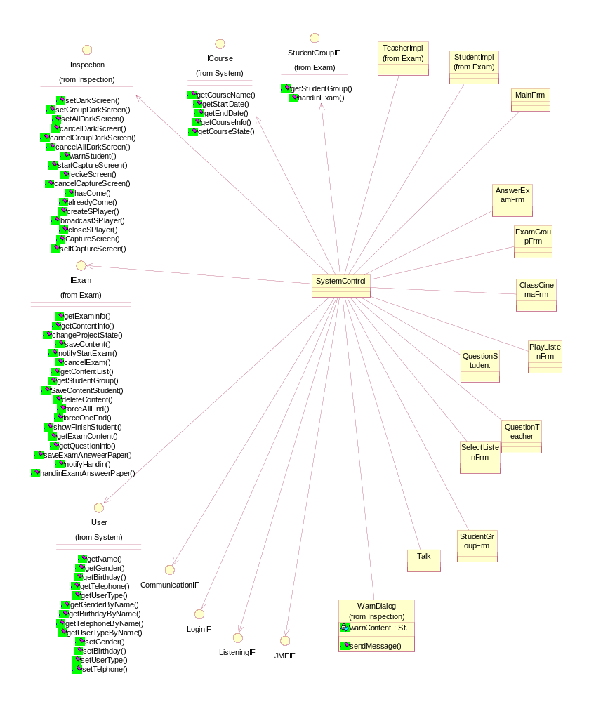

AnswerExamFrm

Associations:

(Unnamed Target Role) [] : Unnamed Association (Unnamed Supplier Role) to SystemControl

ClassCinemaFrm

Associations:

(Unnamed Target Role) [] : Unnamed Association (Unnamed Supplier Role) to SystemControl

CommunicationIF

Associations:

(Unnamed Target Role) [] : Unnamed Association (Unnamed Supplier Role) to SystemControl

ExamGroupFrm

Associations:

(Unnamed Target Role) [] : Unnamed Association (Unnamed Supplier Role) to SystemControl

JMFIF

Associations:

(Unnamed Target Role) [] : Unnamed Association (Unnamed Supplier Role) to SystemControl

ListeningIF

Associations:

(Unnamed Target Role) [] : Unnamed Association (Unnamed Supplier Role) to SystemControl

LoginIF

Associations:

(Unnamed Target Role) [] : Unnamed Association (Unnamed Supplier Role) to SystemControl

MainFrm

Associations:

(Unnamed Target Role) [] : Unnamed Association (Unnamed Supplier Role) to SystemControl

NewClass

PlayListenFrm

Associations:

(Unnamed Target Role) [] : Unnamed Association (Unnamed Supplier Role) to SystemControl

QuestionStudent

Associations:

(Unnamed Target Role) [] : Unnamed Association (Unnamed Supplier Role) to SystemControl

QuestionTeacher

Associations:

(Unnamed Target Role) [] : Unnamed Association (Unnamed Supplier Role) to SystemControl

SelectListenFrm

Associations:

(Unnamed Target Role) [] : Unnamed Association (Unnamed Supplier Role) to SystemControl

StudentGroupFrm

Associations:

(Unnamed Target Role) [] : Unnamed Association (Unnamed Supplier Role) to SystemControl

SystemControl

SystemControl类

Associations:

(Unnamed Target Role) [] : Unnamed Association (Unnamed Supplier Role) to ICourse

(Unnamed Target Role) [] : Unnamed Association (Unnamed Supplier Role) to IInspection

(Unnamed Target Role) [] : Unnamed Association (Unnamed Supplier Role) to StudentGroupIF

(Unnamed Target Role) [] : Unnamed Association (Unnamed Supplier Role) to IExam

(Unnamed Target Role) [] : Unnamed Association (Unnamed Supplier Role) to IUser

(Unnamed Target Role) [] : Unnamed Association (Unnamed Supplier Role) to TeacherImpl

(Unnamed Target Role) [] : Unnamed Association (Unnamed Supplier Role) to StudentImpl

(Unnamed Target Role) [] : Unnamed Association (Unnamed Supplier Role) to MainFrm

(Unnamed Target Role) [] : Unnamed Association (Unnamed Supplier Role) to AnswerExamFrm

(Unnamed Target Role) [] : Unnamed Association (Unnamed Supplier Role) to ExamGroupFrm

(Unnamed Target Role) [] : Unnamed Association (Unnamed Supplier Role) to ClassCinemaFrm

(Unnamed Target Role) [] : Unnamed Association (Unnamed Supplier Role) to PlayListenFrm

(Unnamed Target Role) [] : Unnamed Association (Unnamed Supplier Role) to QuestionStudent

(Unnamed Target Role) [] : Unnamed Association (Unnamed Supplier Role) to QuestionTeacher

(Unnamed Target Role) [] : Unnamed Association (Unnamed Supplier Role) to SelectListenFrm

(Unnamed Target Role) [] : Unnamed Association (Unnamed Supplier Role) to StudentGroupFrm

(Unnamed Target Role) [] : Unnamed Association (Unnamed Supplier Role) to Talk

(Unnamed Target Role) [] : Unnamed Association (Unnamed Supplier Role) to WarnDialog

(Unnamed Target Role) [] : Unnamed Association (Unnamed Supplier Role) to CommunicationIF

(Unnamed Target Role) [] : Unnamed Association (Unnamed Supplier Role) to LoginIF

(Unnamed Target Role) [] : Unnamed Association (Unnamed Supplier Role) to ListeningIF

(Unnamed Target Role) [] : Unnamed Association (Unnamed Supplier Role) to JMFIF

Talk

Associations:

(Unnamed Target Role) [] : Unnamed Association (Unnamed Supplier Role) to SystemControl

eschool

Communication

//课堂交流

Class Diagram - Group

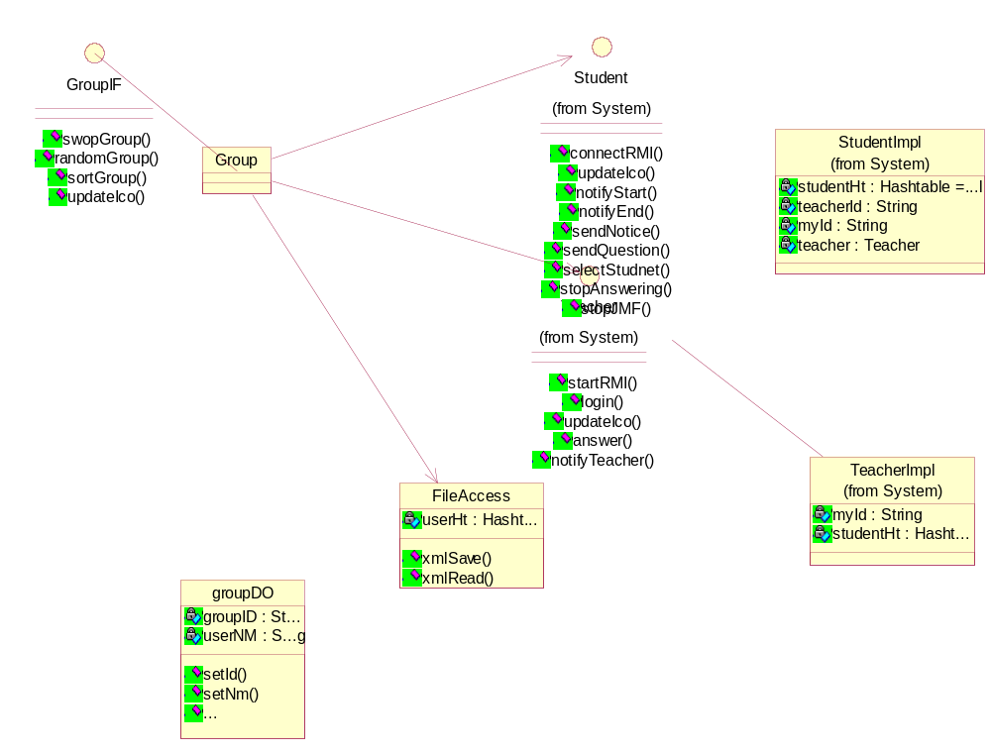

Class Diagram - Demonstrate

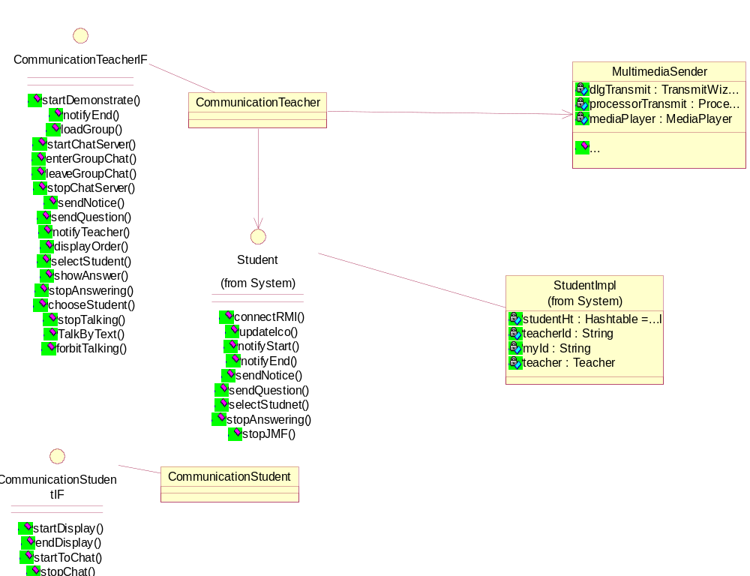

Class Diagram - GroupTalking

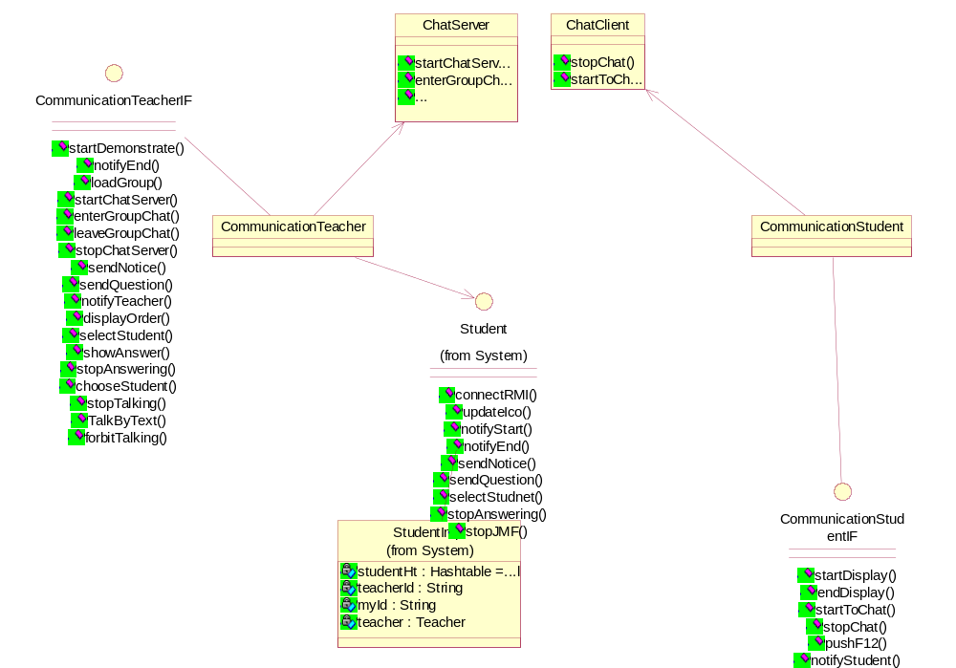

Class Diagram - QuestionAndAnswer

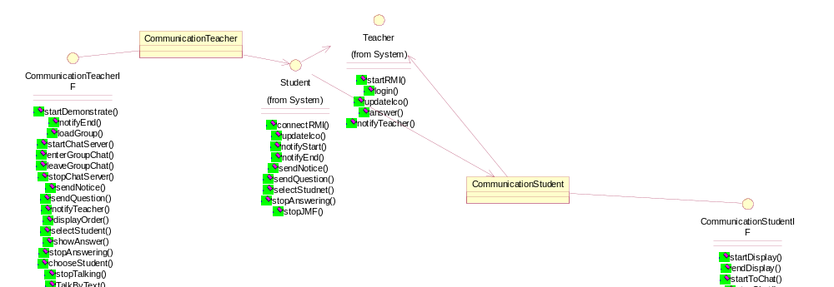

Class Diagram - AskTeacher

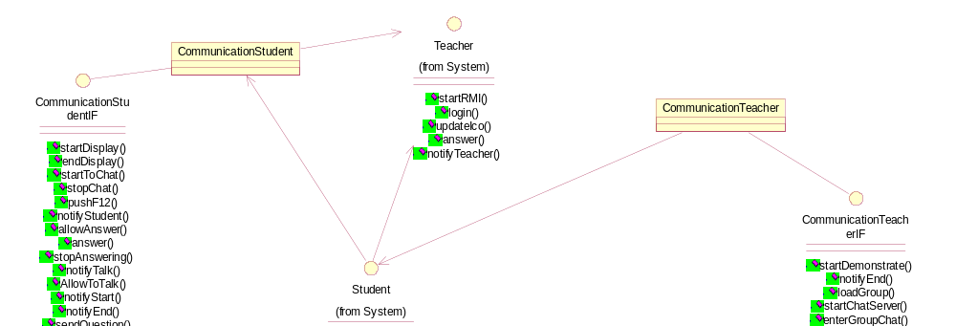

Class Diagram - TalkWithTeacherByVoice

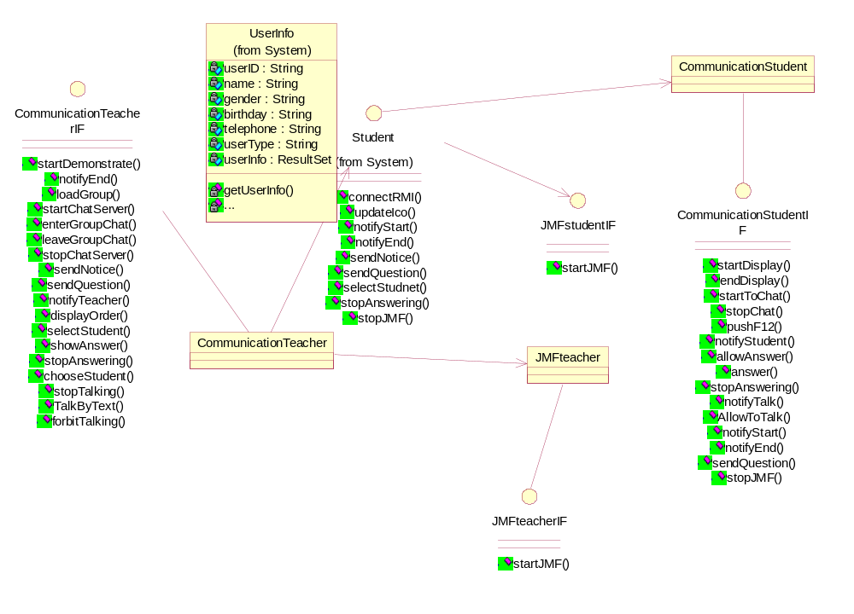

Class Diagram - TalkWithTeacherByText

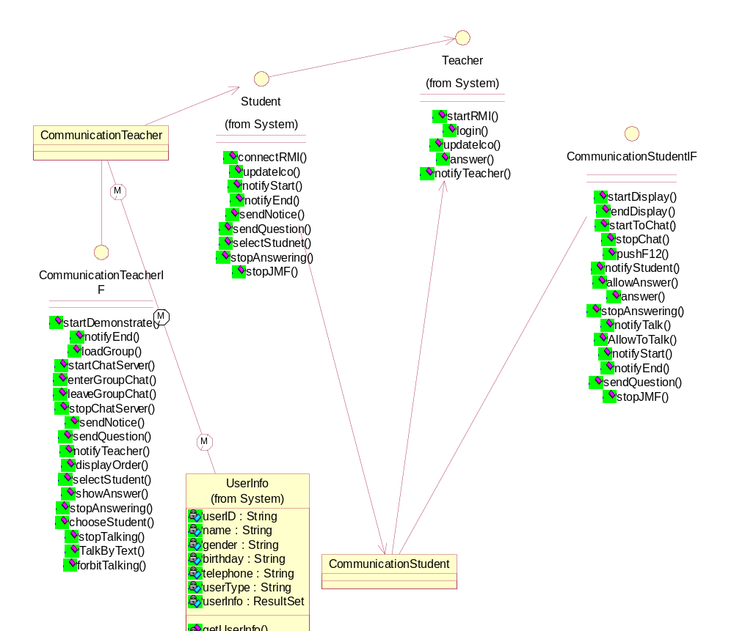

Interaction Diagram - Demonstrate

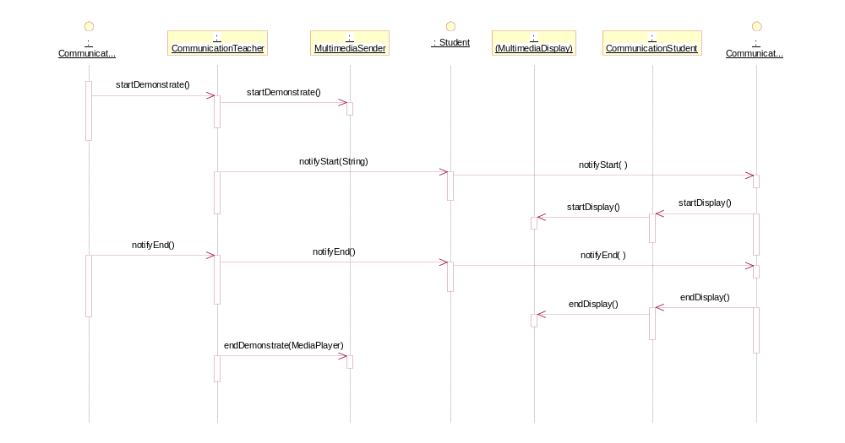

Interaction Diagram - GroupStudent

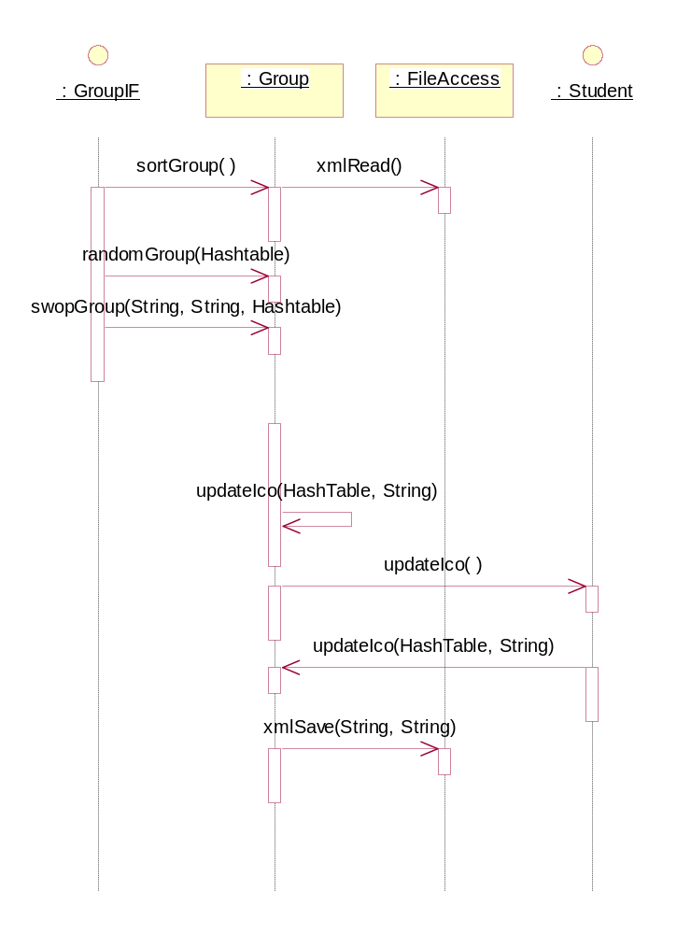

Interaction Diagram - GroupTalking

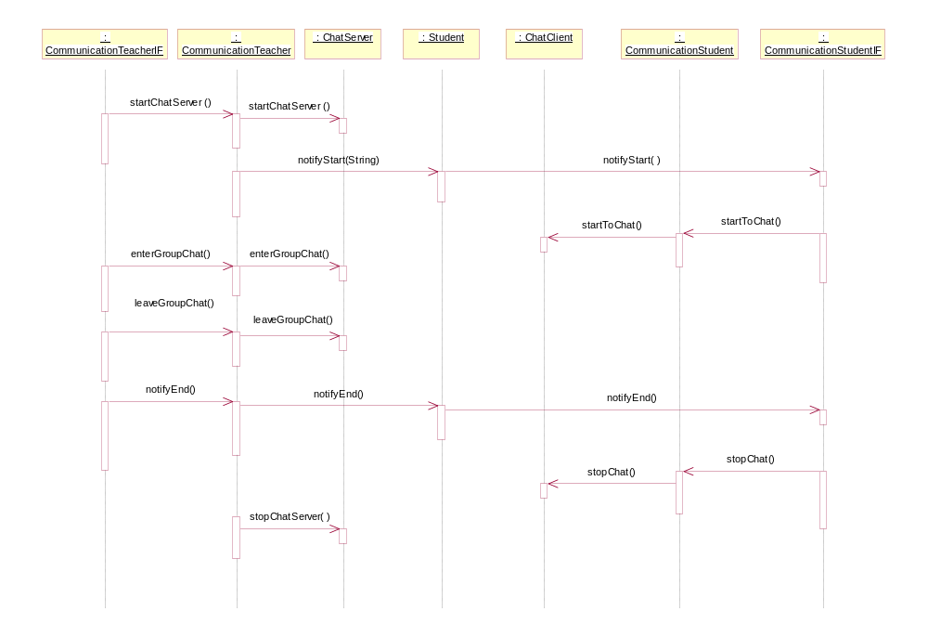

Interaction Diagram - QuestionAndAnswer

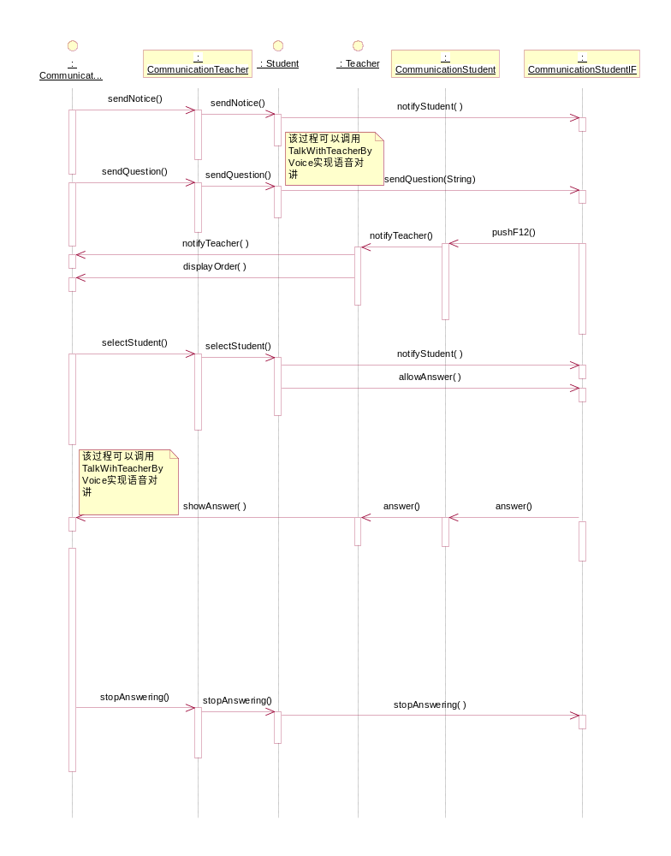

Interaction Diagram - TalkWithTeacherByVoice

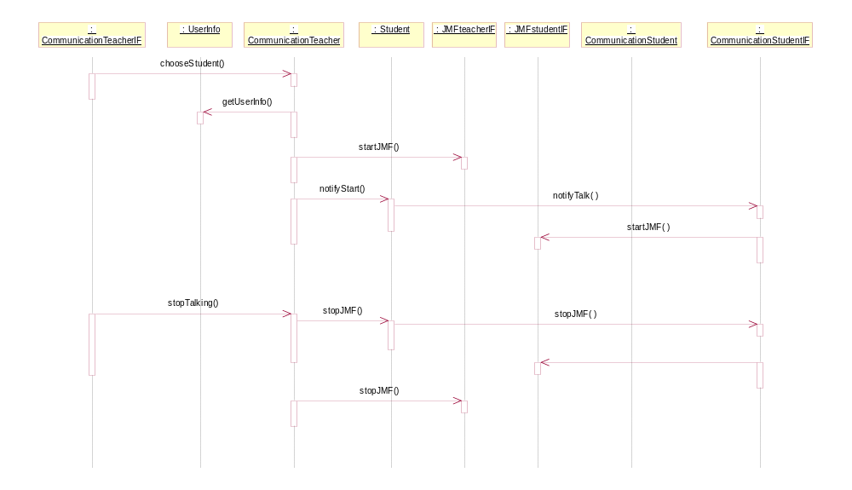

Interaction Diagram - AskTeacher

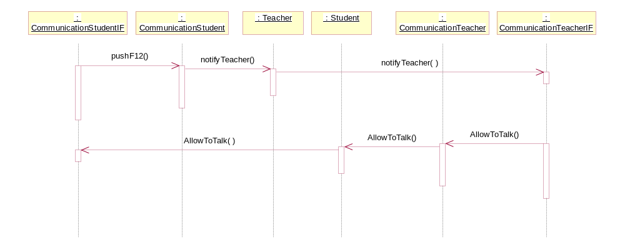

Interaction Diagram - TalkWithTeacherByText

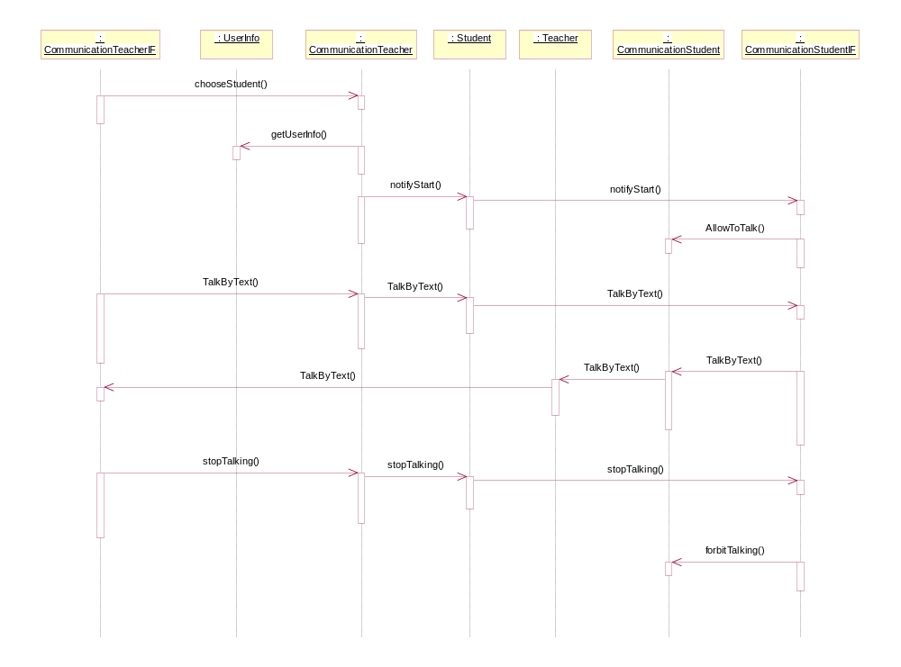

ChatClient

Associations:

(Unnamed Target Role) [] : Unnamed Association (Unnamed Supplier Role) to CommunicationStudent

Public Operations:

stopChat () :

dispose();//关闭Chat窗口

startToChat () :

//connecting ChatServer

ChatServer

Associations:

(Unnamed Target Role) [] : Unnamed Association (Unnamed Supplier Role) to CommunicationTeacher

Public Operations:

startChatServer () :

//Create ChatServer

enterGroupChat () :

leaveGroupChat () :

stopChatServer () :

CommunicationStudent

Associations:

(Unnamed Target Role) [] : Unnamed Association (Unnamed Supplier Role) to ChatClient

(Unnamed Target Role) [] : Unnamed Association (Unnamed Supplier Role) to Student

(Unnamed Target Role) [] : Unnamed Association (Unnamed Supplier Role) to Teacher

CommunicationStudentIF

Public Operations:

startDisplay () :

Call DemonstrateStudent.startDisplay();

endDisplay () :

Call DemonstrateStudent.endDisplay();

startToChat () :

stopChat () :

pushF12 () :

notifyStudent () :

allowAnswer () :

answer () :

stopAnswering () :

notifyTalk () :

AllowToTalk () :

notifyStart () :

notifyEnd () :

sendQuestion ( question : String) :

question

stopJMF () :

CommunicationTeacher

Associations:

(Unnamed Target Role) [] : Unnamed Association (Unnamed Supplier Role) to Student

(Unnamed Target Role) [] : Unnamed Association (Unnamed Supplier Role) to MultimediaSender

(Unnamed Target Role) [] : Unnamed Association (Unnamed Supplier Role) to ChatServer

(Unnamed Target Role) [] : Unnamed Association (Unnamed Supplier Role) to JMFteacher

(Unnamed Target Role) [] : Unnamed Association (Unnamed Supplier Role) to UserInfo

CommunicationTeacherIF

Public Operations:

startDemonstrate () :

call DemonstrateTeacher.startDemonstrate();

notifyEnd () :

Call Student.notifyEnd();

loadGroup () :

startChatServer () :

enterGroupChat () :

leaveGroupChat () :

stopChatServer () :

sendNotice () :

sendQuestion () :

notifyTeacher () :

displayOrder () :

selectStudent () :

showAnswer () :

stopAnswering () :

chooseStudent () :

stopTalking () :

TalkByText () :

forbitTalking () :

FileAccess

xml文件的存取

Private Attributes:

userHt : Hashtable

//存储用户seatNo,和组信息

Associations:

(Unnamed Target Role) [] : Unnamed Association (Unnamed Supplier Role) to Group

Public Operations:

xmlSave ( seatNo : String, user : String) :

将组信息userHt存入xml文件

seatNo

user

xmlRead () : Hashtable

打开一个分组文件XML，组成userHt
userHt.put(seatNo,groupDO);

return userHt;

Group

Associations:

(Unnamed Target Role) [] : Unnamed Association (Unnamed Supplier Role) to Teacher

(Unnamed Target Role) [] : Unnamed Association (Unnamed Supplier Role) to Student

(Unnamed Target Role) [] : Unnamed Association (Unnamed Supplier Role) to FileAccess

GroupIF

Public Operations:

swopGroup ( userid1 : String, userid2 : String, userHt : Hashtable) :

//两个学生位置对调，重组userHt
调用
for (int i=0;i<userHt.size();i++)
取出各学生接口
student.updateIco();
next

userid1

userid2

userHt

randomGroup ( user : Hashtable) :

将传入的user,按照每8个分成一组，组成新的user
teacher.updateIco(user);
student.updateIco(user);
for (int i=0;i<user.size();i++)
//将组号与学生ID,组说明写入XML文件
xmlSave(seatNo,userid,remark);
next

user
seatNo,groupDO

sortGroup () :

for (int i=0;i<user.size();i++)
//将组号与学生ID,组说明写入XML文件
xmlSave(seatNo,userid,remark);
next

updateIco ( userHt : HashTable, mode : String) :

userHt

mode
分类方式

GroupTalking

JMFstudent

JMFstudentIF

Associations:

(Unnamed Target Role) [] : Unnamed Association (Unnamed Supplier Role) to Student

Public Operations:

startJMF () :

JMFteacher

Associations:

(Unnamed Target Role) [] : Unnamed Association (Unnamed Supplier Role) to CommunicationTeacher

JMFteacherIF

Public Operations:

startJMF () :

MultimediaSender

Private Attributes:

dlgTransmit : TransmitWizard

processorTransmit : Processor

mediaPlayer : MediaPlayer

Associations:

(Unnamed Target Role) [] : Unnamed Association (Unnamed Supplier Role) to CommunicationTeacher

Public Operations:

startDemonstrate ( mediaPlayerCurrent : MediaPlayer) :

mediaPlayerCurrent

endDemonstrate ( mediaPlayerCurrent : MediaPlayer) :

mediaPlayerCurrent

QuestionandAnswer

TalkwithTeacher

groupDO

//组信息

Private Attributes:

groupID : String

userNM : String

Public Operations:

setId ( id : String) :

groupID=id;

id

setNm ( nm : String) :

userNM=nm;

nm

getId () :

return groupID;

getNm () :

return userNM;

Listening

//听力

Class Diagram - Listening

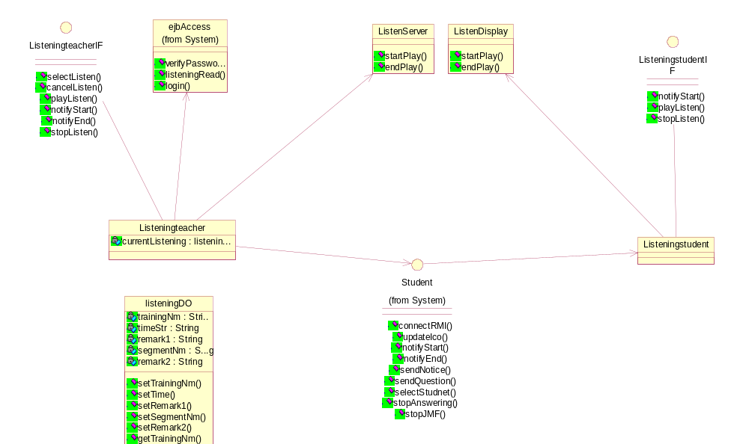

Interaction Diagram - Listening

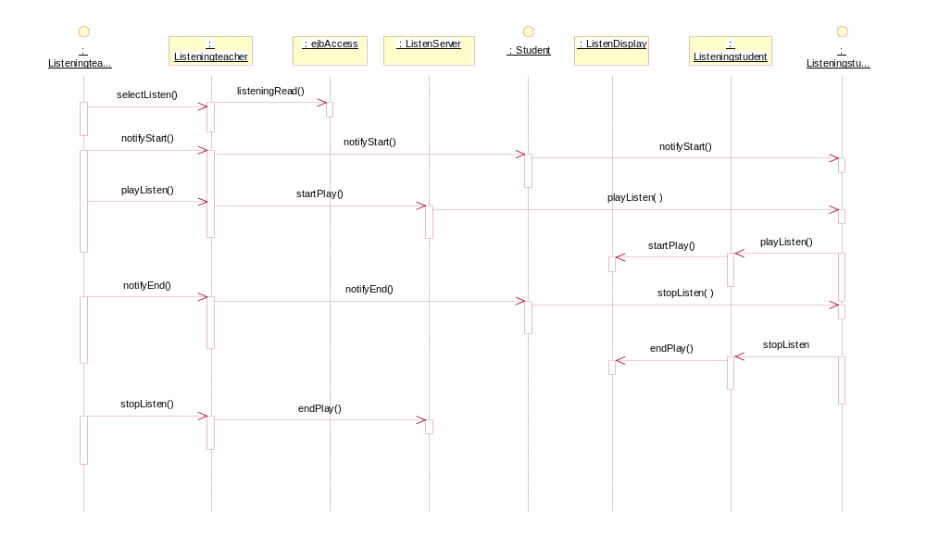

ListenDisplay

Associations:

(Unnamed Target Role) [] : Unnamed Association (Unnamed Supplier Role) to Listeningstudent

Public Operations:

startPlay () :

endPlay () :

ListenServer

Associations:

(Unnamed Target Role) [] : Unnamed Association (Unnamed Supplier Role) to Listeningteacher

Public Operations:

startPlay () :

endPlay () :

Listeningstudent

Associations:

(Unnamed Target Role) [] : Unnamed Association (Unnamed Supplier Role) to ListenDisplay

(Unnamed Target Role) [] : Unnamed Association (Unnamed Supplier Role) to Student

ListeningstudentIF

Public Operations:

notifyStart ( info : String) :

info

playListen () :

stopListen () :

Listeningteacher

Derived from FileAccess

Private Attributes:

currentListening : listeningDO

Associations:

(Unnamed Target Role) [] : Unnamed Association (Unnamed Supplier Role) to ListenServer

(Unnamed Target Role) [] : Unnamed Association (Unnamed Supplier Role) to Student

(Unnamed Target Role) [] : Unnamed Association (Unnamed Supplier Role) to ejbAccess

ListeningteacherIF

Public Operations:

selectListen () : listeningDO

//打开听力xml文件,选择一听力片断，存储在currentListening

cancelListen () :

currentListening=null;

playListen ( listening : listeningDO) :

//JMF播放

listening

notifyStart ( user : Student, info : String) :

user

info

notifyEnd () :

stopListen () :

listeningDO

//存取单个听力片断信息

Private Attributes:

trainingNm : String

timeStr : String

remark1 : String

segmentNm : String

remark2 : String

Public Operations:

setTrainingNm ( name : String) :

trainingNm=name;

name

setTime ( time : String) :

timeStr=time;

time

setRemark1 ( remark : String) :

remark1=remark;

remark

setSegmentNm ( segment : String) :

segmentNm=segment;

segment

setRemark2 ( remark : String) :

remark2=remark;

remark

getTrainingNm () :

return trainingNm;

getTime () :

return timeStr;

getRemark1 () :

return remark1;

getSegmentNm () :

return segmentNm;

getRemark2 () :

return remark2;

System

//系统登录

Class Diagram - Login

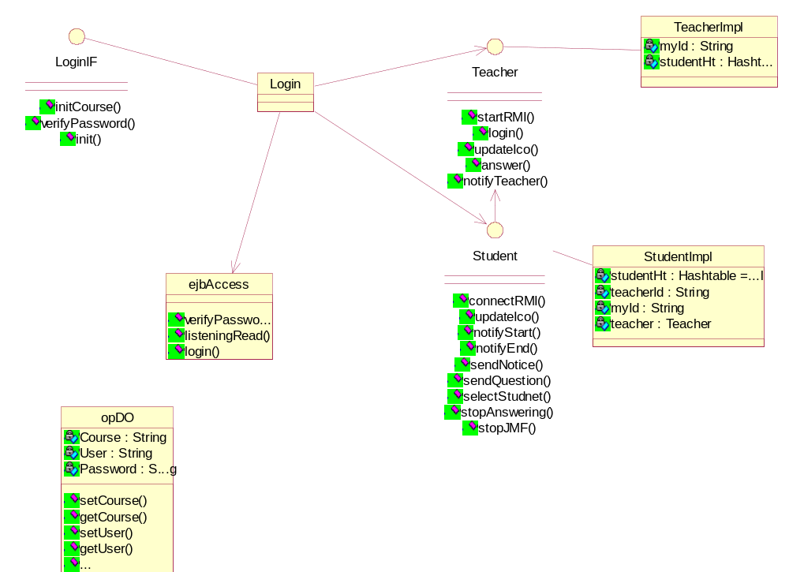

Interaction Diagram - Login

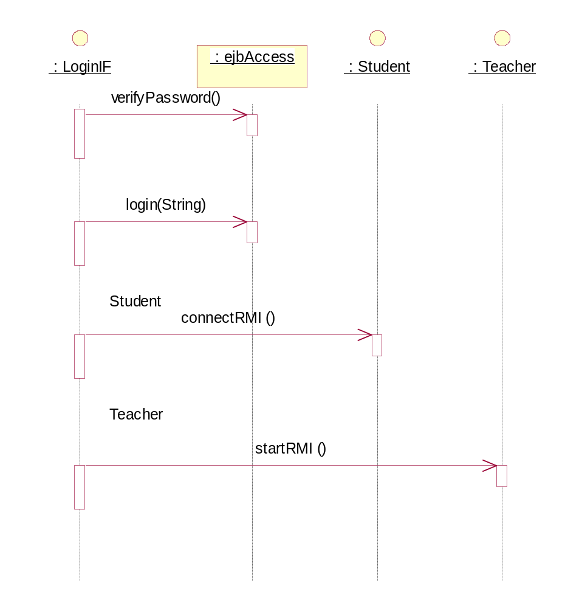

Login

boolean rtnbln;
opDO opdo=new opDO();
opdo.setCourse("selected course");
opdo.setUser(" login user");
opdo.setPassword("user password");

initCourse();
rtnbln=verifyPassword(opdo);
if (rtnbln==false)
dispose();

Associations:

(Unnamed Target Role) [] : Unnamed Association (Unnamed Supplier Role) to Teacher

(Unnamed Target Role) [] : Unnamed Association (Unnamed Supplier Role) to Student

(Unnamed Target Role) [] : Unnamed Association (Unnamed Supplier Role) to ejbAccess

LoginIF

Public Operations:

initCourse () : Vector

//call ejbAccess.initCourse();

verifyPassword ( opdo : opDO) : Vector

//call ejbAccess.verifyPassword();

opdo

init () :

Student

Associations:

(Unnamed Target Role) [] : Unnamed Association (Unnamed Supplier Role) to Login

(Unnamed Target Role) [] : Unnamed Association (Unnamed Supplier Role) to Teacher

(Unnamed Target Role) [] : Unnamed Association (Unnamed Supplier Role) to Listeningteacher

(Unnamed Target Role) [] : Unnamed Association (Unnamed Supplier Role) to Listeningstudent

(Unnamed Target Role) [] : Unnamed Association (Unnamed Supplier Role) to Group

(Unnamed Target Role) [] : Unnamed Association (Unnamed Supplier Role) to CommunicationTeacher

(Unnamed Target Role) [] : Unnamed Association (Unnamed Supplier Role) to CommunicationStudent

(Unnamed Target Role) [] : Unnamed Association (Unnamed Supplier Role) to JMFstudentIF

Public Operations:

connectRMI ( teacherIP : String) :

userName=new Vector();
if (System.getSecurityManager() == null)
System.setSecurityManager(new RMISecurityManager());
try {
teacher = (TeacherIF) Naming.lookup("//IP:port/TeacherServer");
System.out.println("I found Teacher");
} catch (Exception e){
System.out.println("Student exception: " + e.getMessage());
e.printStackTrace();
}
//登入老师服务器
try {
UnicastRemoteObject.exportObject(this);
}
catch (java.rmi.server.ExportException e) {
}

teacherStr=teacher.login(this,myself);
显示老师的图像
显示自己的图像

teacherIP

updateIco () :

//userName=userStr;
if(chgStr.equals("1") {

int indexNum=userName.indexOf(userStr);
if(indexNum>-1)
//显示第indexNum图标
else
//增加 userStr 图标
userName.addEelement(userStr);
}
else
//模糊indexNum图标

notifyStart ( info : String) :

info

notifyEnd () :

sendNotice () :

sendQuestion () :

selectStudnet () :

stopAnswering () :

stopJMF () :

StudentImpl

Private Attributes:

studentHt : Hashtable = null

teacherId : String

myId : String

teacher : Teacher

Teacher

Associations:

(Unnamed Target Role) [] : Unnamed Association (Unnamed Supplier Role) to Login

(Unnamed Target Role) [] : Unnamed Association (Unnamed Supplier Role) to Student

(Unnamed Target Role) [] : Unnamed Association (Unnamed Supplier Role) to Group

(Unnamed Target Role) [] : Unnamed Association (Unnamed Supplier Role) to CommunicationStudent

Public Operations:

startRMI () :

if (System.getSecurityManager() == null)
System.setSecurityManager(new RMISecurityManager());
try {
Stringname="//"+":1200/TeacherServer";
LocateRegistry.createRegistry(1200);
Naming.rebind(name, this);
System.out.println("TeacherServer bound in registry");
} catch (Exception e) {
System.out.println("TeacherServer err: " + e.getMessage());
e.printStackTrace();
}

login ( student_IF : Student, userStr : String) :

//userName=userStr;
if(chgStr.equals("1") {

int indexNum=userName.indexOf(userStr);
if(indexNum>-1)
//显示第indexNum图标
else
//增加 userStr 图标
userName.addEelement(userStr);
}
else
//模糊indexNum图标

student_IF

userStr

updateIco ( user : Hashtable) :

user

answer () :

notifyTeacher () :

TeacherImpl

Private Attributes:

myId : String

//老师自己的ID

studentHt : Hashtable

//存储学生ID，和学生接口实例
studentHt.put(userid,student);

UserInfo

Associations:

(Unnamed Target Role) [] : Unnamed Association (Unnamed Supplier Role) to CommunicationTeacher

Public Operations:

getUserInfo () :

//liu-hz 设计

ejbAccess

所有课程

Associations:

(Unnamed Target Role) [] : Unnamed Association (Unnamed Supplier Role) to Login

(Unnamed Target Role) [] : Unnamed Association (Unnamed Supplier Role) to Listeningteacher

Public Operations:

verifyPassword ( userid : String, password : String) : Vector

//call JavaBean 's Function
parameter userID,password
if Teacher then
取出老师的所有课程
Return teacher's Courses.
else if Student
取出学生所有的课程，和SessionBean 上的HashTable中的正在上的课程表对照，取出他们交叉部分，也就是该学生可上的课程，并且返回。
Return Student's Course.

userid
//用户ID
password
//密码

listeningRead ( userid : String) : Vector

返回听力数据//
练习名称，时间，说明，片断名称，说明

userid

login ( courseIp : String) : String

If Student
parameter CourseID 学生所选的课程号
到SessionBean 的HashTable中获取该CourseID对应的老师IP.
Return 老师的IP.
if Teacher
parameter CourseID,IP 老师所选的课程号，和老师的IP.
将CourseID,IP存储在SessionBean上
return Null

courseIp

opDO

//login information

Private Attributes:

Course : String

User : String

Password : String

Public Operations:

setCourse ( course : String) :

Course=course;

course
//course

getCourse () : String

return Course;

setUser ( user : String) :

User=user;

user

getUser () : String

return User;

setPassword ( password : String) :

Password=password;

password

getPassword () : String

return Password;

uidesign

Class Diagram - UI

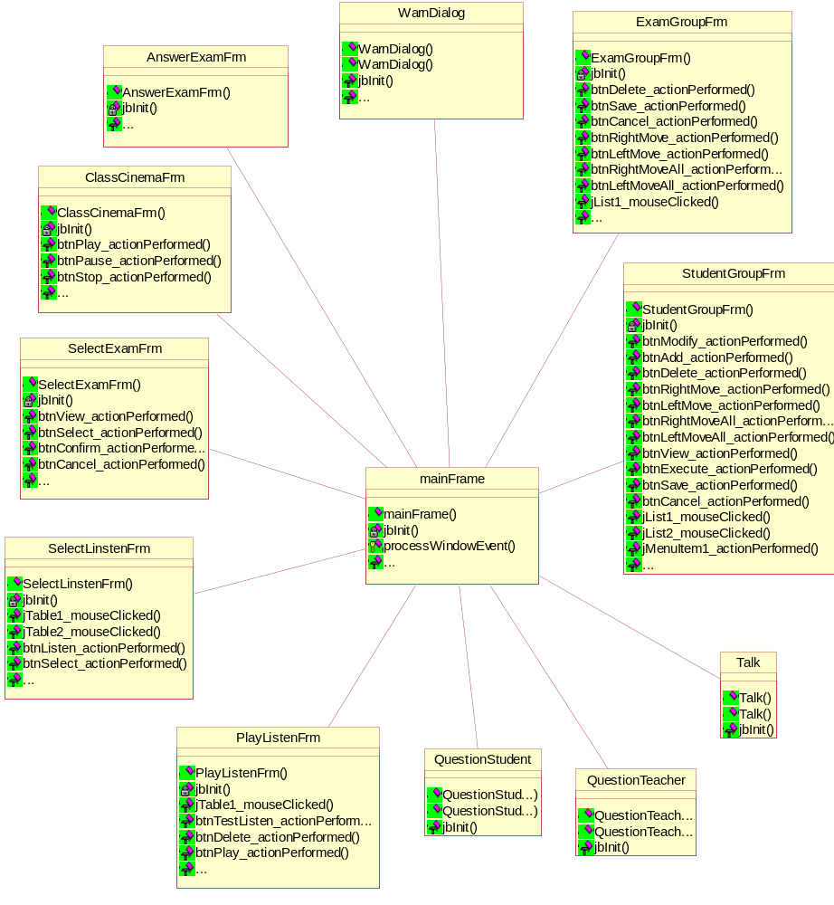

AnswerExamFrm

答题窗口

Associations:

jScrollPane1 [] : Unnamed Association (Unnamed Supplier Role) to JScrollPane

jScrollPane2 [] : Unnamed Association (Unnamed Supplier Role) to JScrollPane

jLabel1 [] : Unnamed Association (Unnamed Supplier Role) to JLabel

jLabel2 [] : Unnamed Association (Unnamed Supplier Role) to JLabel

btnHandIn [] : Unnamed Association (Unnamed Supplier Role) to JButton

btnSave [] : Unnamed Association (Unnamed Supplier Role) to JButton

(Unnamed Target Role) [] : Unnamed Association (Unnamed Supplier Role) to mainFrame

Public Operations:

AnswerExamFrm () :

窗口的构造方法

Private Operations:

jbInit () : void

窗口的初始化。

btnHandIn_actionPerformed ( e : ActionEvent) : void

提交考卷

e

btnSave_actionPerformed ( e : ActionEvent) : void

保存考卷

e

ClassCinemaFrm

课堂影院窗口

Associations:

jMenuBar1 [] : Unnamed Association (Unnamed Supplier Role) to JMenuBar

jMenu1 [] : Unnamed Association (Unnamed Supplier Role) to JMenu

jMenuItem1 [] : Unnamed Association (Unnamed Supplier Role) to JMenuItem

jMenuItem2 [] : Unnamed Association (Unnamed Supplier Role) to JMenuItem

jMenu2 [] : Unnamed Association (Unnamed Supplier Role) to JMenu

jSlider1 [] : Unnamed Association (Unnamed Supplier Role) to JSlider

btnPlay [] : Unnamed Association (Unnamed Supplier Role) to JButton

btnPause [] : Unnamed Association (Unnamed Supplier Role) to JButton

btnStop [] : Unnamed Association (Unnamed Supplier Role) to JButton

(Unnamed Target Role) [] : Unnamed Association (Unnamed Supplier Role) to mainFrame

Public Operations:

ClassCinemaFrm () :

窗口的构造方法

Private Operations:

jbInit () : void

窗口的初始化。

btnPlay_actionPerformed ( e : ActionEvent) : void

播放媒体

e

btnPause_actionPerformed ( e : ActionEvent) : void

暂停播放媒体

e

btnStop_actionPerformed ( e : ActionEvent) : void

停止播放

e

jMenuItem1_actionPerformed ( e : ActionEvent) : void

打开

e

jMenuItem2_actionPerformed ( e : ActionEvent) : void

VOD

e

ExamGroupFrm

考试分组窗口

Associations:

jLabel1 [] : Unnamed Association (Unnamed Supplier Role) to JLabel

jScrollPane1 [] : Unnamed Association (Unnamed Supplier Role) to JScrollPane

jTable1 [] : Unnamed Association (Unnamed Supplier Role) to JTable

btnDelete [] : Unnamed Association (Unnamed Supplier Role) to JButton

jLabel2 [] : Unnamed Association (Unnamed Supplier Role) to JLabel

jLabel3 [] : Unnamed Association (Unnamed Supplier Role) to JLabel

jLabel4 [] : Unnamed Association (Unnamed Supplier Role) to JLabel

jLabel5 [] : Unnamed Association (Unnamed Supplier Role) to JLabel

jList1 [] : Unnamed Association (Unnamed Supplier Role) to JList

jList2 [] : Unnamed Association (Unnamed Supplier Role) to JList

btnSave [] : Unnamed Association (Unnamed Supplier Role) to JButton

btnCancel [] : Unnamed Association (Unnamed Supplier Role) to JButton

btnRightMove [] : Unnamed Association (Unnamed Supplier Role) to JButton

btnLeftMove [] : Unnamed Association (Unnamed Supplier Role) to JButton

btnRightMoveAll [] : Unnamed Association (Unnamed Supplier Role) to JButton

btnLeftMoveAll [] : Unnamed Association (Unnamed Supplier Role) to JButton

(Unnamed Target Role) [] : Unnamed Association (Unnamed Supplier Role) to mainFrame

Public Operations:

ExamGroupFrm () :

窗口的构造方法

Private Operations:

jbInit () : void

窗口的初始化。

btnDelete_actionPerformed ( e : ActionEvent) : void

删除考题

e

btnSave_actionPerformed ( e : ActionEvent) : void

保存考题

e

btnCancel_actionPerformed ( e : ActionEvent) : void

取消考题

e

btnRightMove_actionPerformed ( e : ActionEvent) : void

e

btnLeftMove_actionPerformed ( e : ActionEvent) : void

e

btnRightMoveAll_actionPerformed ( e : ActionEvent) : void

e

btnLeftMoveAll_actionPerformed ( e : ActionEvent) : void

e

jList1_mouseClicked ( e : MouseEvent) : void

e

jList2_mouseClicked ( e : MouseEvent) : void

e

jTable1_mouseClicked ( e : MouseEvent) : void

e

PlayListenFrm

播放听力窗口

Associations:

jLabel1 [] : Unnamed Association (Unnamed Supplier Role) to JLabel

jScrollPane1 [] : Unnamed Association (Unnamed Supplier Role) to JScrollPane

jTable1 [] : Unnamed Association (Unnamed Supplier Role) to JTable

btnTestListen [] : Unnamed Association (Unnamed Supplier Role) to JButton

btnDelete [] : Unnamed Association (Unnamed Supplier Role) to JButton

btnPause [] : Unnamed Association (Unnamed Supplier Role) to JButton

btnPlay [] : Unnamed Association (Unnamed Supplier Role) to JButton

btnStop [] : Unnamed Association (Unnamed Supplier Role) to JButton

jLabel2 [] : Unnamed Association (Unnamed Supplier Role) to JLabel

jSlider1 [] : Unnamed Association (Unnamed Supplier Role) to JSlider

(Unnamed Target Role) [] : Unnamed Association (Unnamed Supplier Role) to mainFrame

Public Operations:

PlayListenFrm () :

窗口的构造方法

Private Operations:

jbInit () : void

窗口的初始化。

jTable1_mouseClicked ( e : MouseEvent) : void

e

btnTestListen_actionPerformed ( e : ActionEvent) : void

试听听力片断

e

btnDelete_actionPerformed ( e : ActionEvent) : void

删除听力片断

e

btnPlay_actionPerformed ( e : ActionEvent) : void

播放听力片断

e

btnPause_actionPerformed ( e : ActionEvent) : void

暂停播放

e

btnStop_actionPerformed ( e : ActionEvent) : void

停止播放

e

QuestionStudent

电子抢答学生端

Associations:

(Unnamed Target Role) [] : Unnamed Association (Unnamed Supplier Role) to mainFrame

Public Operations:

QuestionStudent ( frame : Frame, title : String, modal : boolean) :

frame

title

modal

QuestionStudent () :

Private Operations:

jbInit () : void

QuestionTeacher

电子抢答老师端

Associations:

(Unnamed Target Role) [] : Unnamed Association (Unnamed Supplier Role) to mainFrame

Public Operations:

QuestionTeacher ( frame : Frame, title : String, modal : boolean) :

frame

title

modal

QuestionTeacher () :

Private Operations:

jbInit () : void

SelectExamFrm

选择考试窗口

Associations:

jLabel1 [] : Unnamed Association (Unnamed Supplier Role) to JLabel

jScrollPane1 [] : Unnamed Association (Unnamed Supplier Role) to JScrollPane

tbProject [] : Unnamed Association (Unnamed Supplier Role) to JTable

jLabel2 [] : Unnamed Association (Unnamed Supplier Role) to JLabel

jScrollPane2 [] : Unnamed Association (Unnamed Supplier Role) to JScrollPane

tbContent [] : Unnamed Association (Unnamed Supplier Role) to JTable

btnView [] : Unnamed Association (Unnamed Supplier Role) to JButton

btnSelect [] : Unnamed Association (Unnamed Supplier Role) to JButton

btnConfirm [] : Unnamed Association (Unnamed Supplier Role) to JButton

btnCancel [] : Unnamed Association (Unnamed Supplier Role) to JButton

(Unnamed Target Role) [] : Unnamed Association (Unnamed Supplier Role) to mainFrame

Public Operations:

SelectExamFrm () :

窗口的构造方法

Private Operations:

jbInit () : void

窗口的初始化。

btnView_actionPerformed ( e : ActionEvent) : void

预览试题

e

btnSelect_actionPerformed ( e : ActionEvent) : void

选择试题

e

btnConfirm_actionPerformed ( e : ActionEvent) : void

确认试题

e

btnCancel_actionPerformed ( e : ActionEvent) : void

取消选取

e

tbProject_mouseClicked ( e : MouseEvent) : void

e

tbContent_mouseClicked ( e : MouseEvent) : void

e

SelectLinstenFrm

选择听力窗口

Associations:

jLabel1 [] : Unnamed Association (Unnamed Supplier Role) to JLabel

jScrollPane1 [] : Unnamed Association (Unnamed Supplier Role) to JScrollPane

jTable1 [] : Unnamed Association (Unnamed Supplier Role) to JTable

jLabel2 [] : Unnamed Association (Unnamed Supplier Role) to JLabel

jScrollPane2 [] : Unnamed Association (Unnamed Supplier Role) to JScrollPane

jTable2 [] : Unnamed Association (Unnamed Supplier Role) to JTable

btnListen [] : Unnamed Association (Unnamed Supplier Role) to JButton

btnSelect [] : Unnamed Association (Unnamed Supplier Role) to JButton

btnConfirm [] : Unnamed Association (Unnamed Supplier Role) to JButton

btnCancel [] : Unnamed Association (Unnamed Supplier Role) to JButton

(Unnamed Target Role) [] : Unnamed Association (Unnamed Supplier Role) to mainFrame

Public Operations:

SelectLinstenFrm () :

窗口的构造方法

Private Operations:

jbInit () : void

窗口的初始化。

jTable1_mouseClicked ( e : MouseEvent) : void

e

jTable2_mouseClicked ( e : MouseEvent) : void

e

btnListen_actionPerformed ( e : ActionEvent) : void

试听听力片断

e

btnSelect_actionPerformed ( e : ActionEvent) : void

选择听力片断

e

btnConfirm_actionPerformed ( e : ActionEvent) : void

确认听力片断

e

btnCancel_actionPerformed ( e : ActionEvent) : void

取消选择

e

StudentGroupFrm

学生分组窗口

Associations:

jMenuBar1 [] : Unnamed Association (Unnamed Supplier Role) to JMenuBar

jMenu1 [] : Unnamed Association (Unnamed Supplier Role) to JMenu

jMenuItem1 [] : Unnamed Association (Unnamed Supplier Role) to JMenuItem

jMenuItem2 [] : Unnamed Association (Unnamed Supplier Role) to JMenuItem

jMenuItem3 [] : Unnamed Association (Unnamed Supplier Role) to JMenuItem

jMenu2 [] : Unnamed Association (Unnamed Supplier Role) to JMenu

jLabel1 [] : Unnamed Association (Unnamed Supplier Role) to JLabel

jScrollPane1 [] : Unnamed Association (Unnamed Supplier Role) to JScrollPane

jTable1 [] : Unnamed Association (Unnamed Supplier Role) to JTable

btnModify [] : Unnamed Association (Unnamed Supplier Role) to JButton

btnAdd [] : Unnamed Association (Unnamed Supplier Role) to JButton

btnDelete [] : Unnamed Association (Unnamed Supplier Role) to JButton

jLabel2 [] : Unnamed Association (Unnamed Supplier Role) to JLabel

jLabel3 [] : Unnamed Association (Unnamed Supplier Role) to JLabel

jLabel4 [] : Unnamed Association (Unnamed Supplier Role) to JLabel

jLabel5 [] : Unnamed Association (Unnamed Supplier Role) to JLabel

jList1 [] : Unnamed Association (Unnamed Supplier Role) to JList

jList2 [] : Unnamed Association (Unnamed Supplier Role) to JList

btnRightMove [] : Unnamed Association (Unnamed Supplier Role) to JButton

btnLeftMove [] : Unnamed Association (Unnamed Supplier Role) to JButton

btnRightMoveAll [] : Unnamed Association (Unnamed Supplier Role) to JButton

btnLeftMoveAll [] : Unnamed Association (Unnamed Supplier Role) to JButton

btnView [] : Unnamed Association (Unnamed Supplier Role) to JButton

btnExecute [] : Unnamed Association (Unnamed Supplier Role) to JButton

btnSave [] : Unnamed Association (Unnamed Supplier Role) to JButton

btnCancel [] : Unnamed Association (Unnamed Supplier Role) to JButton

(Unnamed Target Role) [] : Unnamed Association (Unnamed Supplier Role) to mainFrame

Public Operations:

StudentGroupFrm () :

窗口的构造方法

Private Operations:

jbInit () : void

窗口的初始化。

btnModify_actionPerformed ( e : ActionEvent) : void

修改

e

btnAdd_actionPerformed ( e : ActionEvent) : void

增加

e

btnDelete_actionPerformed ( e : ActionEvent) : void

删除

e

btnRightMove_actionPerformed ( e : ActionEvent) : void

e

btnLeftMove_actionPerformed ( e : ActionEvent) : void

e

btnRightMoveAll_actionPerformed ( e : ActionEvent) : void

e

btnLeftMoveAll_actionPerformed ( e : ActionEvent) : void

e

btnView_actionPerformed ( e : ActionEvent) : void

预览

e

btnExecute_actionPerformed ( e : ActionEvent) : void

执行

e

btnSave_actionPerformed ( e : ActionEvent) : void

保存

e

btnCancel_actionPerformed ( e : ActionEvent) : void

取消

e

jList1_mouseClicked ( e : MouseEvent) : void

e

jList2_mouseClicked ( e : MouseEvent) : void

e

jMenuItem1_actionPerformed ( e : ActionEvent) : void

e

jMenuItem2_actionPerformed ( e : ActionEvent) : void

e

jMenuItem3_actionPerformed ( e : ActionEvent) : void

e

Talk

联机讨论

Associations:

(Unnamed Target Role) [] : Unnamed Association (Unnamed Supplier Role) to mainFrame

Public Operations:

Talk ( frame : Frame, title : String, modal : boolean) :

frame

title

modal

Talk () :

Private Operations:

jbInit () : void

WarnDialog

警告窗口

Associations:

panel1 [] : Unnamed Association (Unnamed Supplier Role) to JPanel

gridLayout1 [] : Unnamed Association (Unnamed Supplier Role) to GridLayout

jLabel1 [] : Unnamed Association (Unnamed Supplier Role) to JLabel

taWarning [] : Unnamed Association (Unnamed Supplier Role) to JTextArea

jPanel1 [] : Unnamed Association (Unnamed Supplier Role) to JPanel

btnSend [] : Unnamed Association (Unnamed Supplier Role) to JButton

btnCancel [] : Unnamed Association (Unnamed Supplier Role) to JButton

component1 [] : Unnamed Association (Unnamed Supplier Role) to Component

component2 [] : Unnamed Association (Unnamed Supplier Role) to Component

(Unnamed Target Role) [] : Unnamed Association (Unnamed Supplier Role) to mainFrame

Public Operations:

WarnDialog ( frame : Frame, title : String, modal : boolean) :

窗口的构造方法

frame

title

modal

WarnDialog () :

窗口的构造方法

Private Operations:

jbInit () : void

窗口的初始化。

btnSend_actionPerformed ( e : ActionEvent) : void

发送警告

e

btnCancel_actionPerformed ( e : ActionEvent) : void

取消发送

e

mainFrame

课堂交流主窗口

Associations:

(Unnamed Target Role) [] : Unnamed Association (Unnamed Supplier Role) to WarnDialog

(Unnamed Target Role) [] : Unnamed Association (Unnamed Supplier Role) to AnswerExamFrm

(Unnamed Target Role) [] : Unnamed Association (Unnamed Supplier Role) to ClassCinemaFrm

(Unnamed Target Role) [] : Unnamed Association (Unnamed Supplier Role) to SelectExamFrm

(Unnamed Target Role) [] : Unnamed Association (Unnamed Supplier Role) to SelectLinstenFrm

(Unnamed Target Role) [] : Unnamed Association (Unnamed Supplier Role) to PlayListenFrm

(Unnamed Target Role) [] : Unnamed Association (Unnamed Supplier Role) to QuestionStudent

(Unnamed Target Role) [] : Unnamed Association (Unnamed Supplier Role) to QuestionTeacher

(Unnamed Target Role) [] : Unnamed Association (Unnamed Supplier Role) to Talk

(Unnamed Target Role) [] : Unnamed Association (Unnamed Supplier Role) to StudentGroupFrm

(Unnamed Target Role) [] : Unnamed Association (Unnamed Supplier Role) to ExamGroupFrm

Public Operations:

mainFrame () :

Construct the frame

Protected Operations:

processWindowEvent ( e : WindowEvent) : void

Overridden so we can exit when window is closed

e

Private Operations:

jbInit () : void

Component initialization

jButton1_actionPerformed ( e : ActionEvent) : void

e

jButton2_actionPerformed ( e : ActionEvent) : void

e

